Damn, It Feels
Good To Be You

Special Delivery- Damn, It Feels Good To Be YOU!

Connect with us on everything https://solo.to/jmanspeaks

Who is this JMan Character? Click here for our full story. We are not normal, and we celebrate the fact that we are different. Please stop trying to do the things that everyone else is doing. Find the unique culture of your organization and celebrate it.

Start with your audience. WHO are they? WHAT do you want them to engage with?

HOW do we connect? Meet the members where they already are and make it entertaining!

Virtual Emcee Role & Responsibilities

Answer To Zoom Fatigue Video

- Set The Pace
- Run Of The Show
- Plan The Speaker Order with Event planner/Professional Development Director
- Intro The Sessions/ Speakers
- Plan Activities for down time
- Entertain
- Engage
- Online social media asset creation
- Contests & Giveaways
10. Energy Infusion

Virtual Emcee Video

VIRTUAL EMCEE TOOLS Run Of The Show, etc

Fun & Games

- Virtual Scavenger hunt
- Dance Party
- Lip Sing Competition
- Virtual Workout
- The crazier the idea, the better and then capture it on video
B Roll Example of dancing
Virtual Dancing Through The Decades

EQUIPMENT

What if you don’t have a Facebook Or a messenger account? Read this article

Message the keyword “Equipment” to www.Facebook.com/JManSpeaks to receive our must current and up to date list or go to http://Equipment.JManSeminars.com

Programs

LIVE STREAMING

Good www.BELIVE.TV

Better www.Restream.IO

Best www.Streamyeard.com

LIVE STREAMING & Virtual Camera

MAC- www.EcammLIVE.com

WINDOWS- www.VMix.com

Prezi Video-Make sure to inquire about the educator’s discount

Video Editing

Movavi Video Suite

Animoto Movie Maker- www.Animoto.com

Magisto Movie Maker- www.Magisto.com

Sound Effects & Royalty Free Music

Epidemic Sound www.Epidemic.com

Messenger Bot Marketing

Create an account at www.Manychat.com

https://www.jmanbot.com/SirBotALot has information about our full messenger ot experience.

Message us the keyword “Speaker Bot” to our page www.Facebook.com/JManSpeaks or go to http://speaker.jmanseminars.com/ to check out our speaker bot or you can also go to http://ae.JManSeminars.com to check out our real estate board bot.

You can also visit https://m.me/JManSpeaks?ref=w16003190

OR Scan The QR Code below

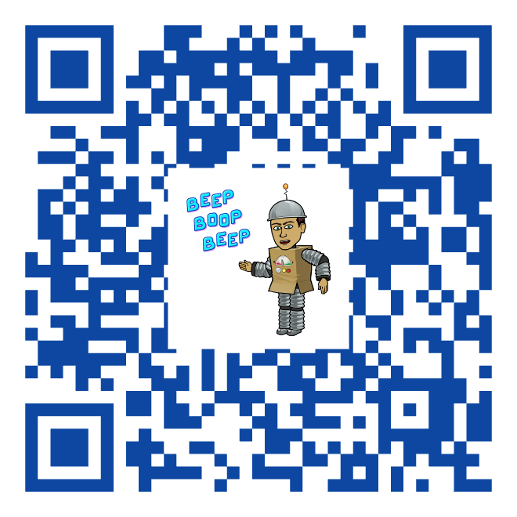

Omni Channel Marketing

SMS Phone Number-1-256-273-8536. Please be sure to disable any auto signature that you might have when you send your texts. The message has to only be the keyword or the responder will or trigger.

You can text the secret keyword “Buffalo Bills” or “Check In” to check in to our imaginary event AND you can also check our Covid Questionnaire by texting the keyword “COVID”. Lastly, You can check out of our imaginary event by using the secret keyword “Checkout” or “Superbowl” to check out.

You can also email within Manychat but you have been doing that for 40+ years already.

ZOOM Tips

You can message us the keyword “ZoomTips” to www.Facebook.com/JManSpeaks in order to get our 16 pages on preferred Zoom settings complete with screenshots. You can also visit the URL http://ZoomTips.JManSeminars.com

Virtual Backgrounds

You should upgrade your account on www.Canva.com

You can get royalty free video clip at https://www.storyblocks.com/video to use for virtual backgrounds or b roll for video or backgrounds for countdown screens.

YouTube SEO

Tube Buddy- https://www.tubebuddy.com/

VidIQ- https://vidiq.com/

Thumbnail Blaster- https://thumbnailblaster.com/

Canva for thumbnail- https://www.canva.com/

Social Media Tools

Facebook Creator Studio
Manage and schedule posts for multiple Facebook & Instagram channels all in one place. https://business.facebook.com/creatorstudio

Messenger Bots
You can use the keyword “Bot Nerd” to try a demo and see what it is like to interact with a a real estate messenger bot powered by Manychat. If you visit us in the booth we have a ton of FREE resources including a 60-minute webinar about Messenger bot marketing for FREE. You can also get the same demo by going to http://Bot.JManSeminars.com

Video Communication
Dubb is a brand new player that is changing the game AND might even give BombBomb a run for their money. You can get a FREE trial by going to http://dubb.jmanseminars.com/

LIVE Streaming Video
Be Live is a great platform for beginners. It is the most stable and the easiest to navigate. https://be.live/

Restream is a great intermediate level LIVE Streaming platform. You can stream to multiple platforms with their FREE version. https://restream.io/

StreamYard is another great intermediate level LIVE Streaming platform. It is a little bit more advanced than Restream and has more capability. You can have more guests and stream to multiple platforms as well. https://streamyard.com/

Rando
Lingo Jam is a website where you can create a translator. You can translate from your native language to Shakespearean, Yoda, Old English, Robot, Ned Flanders and soooo many more. https://lingojam.com/

Zoom Tech Tools (Cause we saw you in the last Zoom Meeting)
We have created a 16 page document with our recommended Zoom settings. You can send the keyword “Zoom Tips” or got to http://Zoomtips.JManSeminars.com

Immersive View creates a whole new Zoom experience

Canva is great for virtual backgrounds

“Touch Up My Appearance” will make you young again. Think Benjamin Button.

Prezi Video-Why hide behind a Slide? Prezi and Prezi video will take your presentations to a whole nother level and can come in as a virtual camera inside of Zoom. https://prezi.com/

Ecamm LIVE is a LIVE Streaming beast and a complete production platform. It is more advanced, but it is totally worth it. You can even bring it into Zoom as a virtual camera and do some crazy stuff that will wow your clients. https://www.ecamm.com/

vMix is the windows version https://www.vmix.com/

THANK YOU!!!

